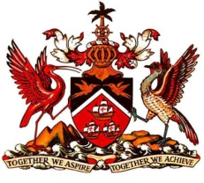

PERMANENT MISSION OF THE REPUBLIC OF TRINIDAD AND TOBAGO
TO THE OFFICE OF THE UNITED NATIONS, GENEVA
Statement by Trinidad and Tobago - Universal Periodic Review of Nauru
Palais des Nations, Geneva, 3rd November 2015

Thank you Mr. President.

Trinidad and Tobago welcomes the delegation of the Republic of Nauru to the second cycle of their Universal Periodic Review (UPR).

Mr. President, it brings great pleasure for my country to deliver a few remarks on Nauru, a fellow Small Island Developing State and a Member of the Alliance of Small Island States (AOSIS). As a former Chair of the AOSIS, Nauru displayed a sterling commitment towards the UN Sustainable Development Goals and combating the devastating global effects of climate change.

Since, Nauru’s last UPR cycle, Trinidad and Tobago would like to highlight the following developments – the accession to CEDAW (Convention on the Elimination of All forms of Discrimination Against Women) and the CRDP (Convention on the Rights of Persons with Disabilities) and the drafting of a National Disability Policy (2015). My delegation also commends the National Sustainable Development Strategy (2005-2025) which focuses on the rehabilitation of mined out lands and national food security.

My delegation wishes to recommend the following:

- That Nauru ratify the CERD (Convention on the Elimination of All Forms of Racial Discrimination) and the ICESCR (International Covenant on Economic, Social and Cultural Rights).
- That steps be taken to enhance and strengthen the independence of the judiciary and
- To establish a comprehensive regulatory framework to reduce the physical and environmental health care risks associated with phosphate mining.

I thank you Mr. President.

